**Manav Rachna university**

Hotel management system

Made by AARYAN ,MONU,DIKRAJ

**DATABASE CREATION:**

create database hms;

Query OK, 1 row affected (0.007 sec)

**CREATING TABLES;**

MariaDB [(none)]> use hms;

Database changed

MariaDB [hms]> create table hotel(hotel_id int(10),name varchar(255),star_rate varchar(7));

Query OK, 0 rows affected (0.035 sec)

MariaDB [hms]> create table rooms(room_no int(10),type varchar(20));

Query OK, 0 rows affected (0.029 sec)

MariaDB [hms]> create table location(street varchar(10),town varchar(100),pincode int(7));

Query OK, 0 rows affected (0.033 sec)

MariaDB [hms]> create table facilities(fid int(10),fname varchar(100));

Query OK, 0 rows affected (0.032 sec)

MariaDB [hms]> create table cost(costid int(10),amount int(10));

Query OK, 0 rows affected (0.034 sec)

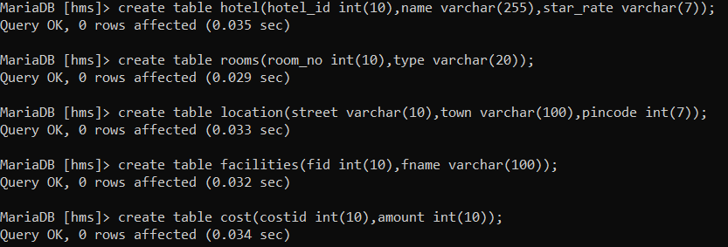

**DATA INSERTION:**

desc cost;

+--------+---------+------+-----+---------+-------+

| Field | Type | Null | Key | Default | Extra |

+--------+---------+------+-----+---------+-------+

| costid | int(10) | YES | | NULL | |

| amount | int(10) | YES | | NULL | |

+--------+---------+------+-----+---------+-------+

2 rows in set (0.043 sec)

MariaDB [hms]> insert into cost(costid,amount)

-> values

-> (1,4232),

-> (2,4453),

-> (3,4343),

-> (4,4565),

-> (5,2442);

Query OK, 5 rows affected (0.010 sec)

Records: 5 Duplicates: 0 Warnings: 0

MariaDB [hms]> desc facilities;

+-------+--------------+------+-----+---------+-------+

| Field | Type | Null | Key | Default | Extra |

+-------+--------------+------+-----+---------+-------+

| fid | int(10) | YES | | NULL | |

| fname | varchar(100) | YES | | NULL | |

+-------+--------------+------+-----+---------+-------+

2 rows in set (0.033 sec)

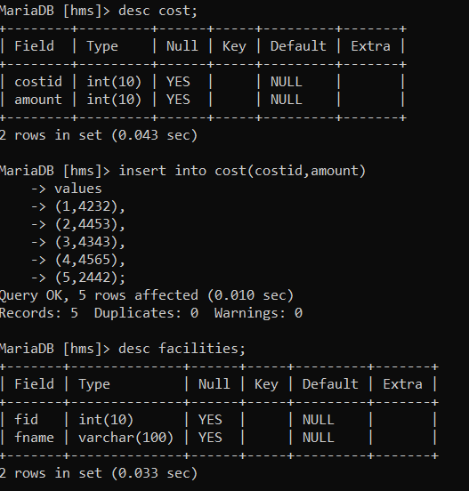

MariaDB [hms]> insert into facilities(fid,fname)

-> values

-> (1,'food'),

-> (2,'drinks'),

-> (3,'yoga_equipments'),

-> (4,'rented_car');

Query OK, 4 rows affected (0.010 sec)

Records: 4 Duplicates: 0 Warnings: 0

MariaDB [hms]> desc location;

+---------+--------------+------+-----+---------+-------+

| Field | Type | Null | Key | Default | Extra |

+---------+--------------+------+-----+---------+-------+

| street | varchar(10) | YES | | NULL | |

| town | varchar(100) | YES | | NULL | |

| pincode | int(7) | YES | | NULL | |

+---------+--------------+------+-----+---------+-------+

3 rows in set (0.032 sec

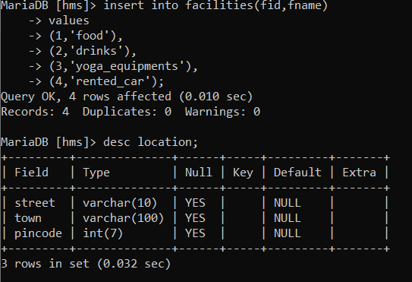

MariaDB [hms]> insert into location(street,town,pincode)

-> values

-> ('one','fbd',1232112),

-> ('two','fbd',1232112),

-> ('three','ggn',1232323),

-> ('four','delhi',6453424);

Query OK, 4 rows affected (0.011 sec)

Records: 4 Duplicates: 0 Warnings: 0

MariaDB [hms]> desc rooms;

+---------+-------------+------+-----+---------+-------+

| Field | Type | Null | Key | Default | Extra |

+---------+-------------+------+-----+---------+-------+

| room_no | int(10) | YES | | NULL | |

| type | varchar(20) | YES | | NULL | |

+---------+-------------+------+-----+---------+-------+

2 rows in set (0.030 sec)

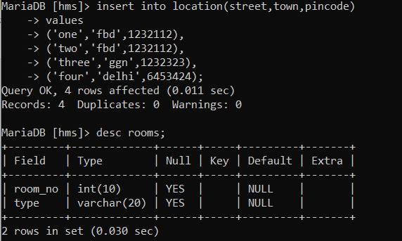

[hms]> insert into rooms(room_no,type)

-> values

-> (12,'luxury'),

-> (62,'luxury'),

-> (54,'normal'),

-> (34,'extra_one');

Query OK, 4 rows affected (0.010 sec)

Records: 4 Duplicates: 0 Warnings: 0

MariaDB [hms]> desc hotel;

+-----------+--------------+------+-----+---------+-------+

| Field | Type | Null | Key | Default | Extra |

+-----------+--------------+------+-----+---------+-------+

| hotel_id | int(10) | YES | | NULL | |

| name | varchar(255) | YES | | NULL | |

| star_rate | varchar(7) | YES | | NULL | |

+-----------+--------------+------+-----+---------+-------+

3 rows in set (0.027 sec)

MariaDB [hms]> insert into hotel(hotel_id,name,star_rate)

-> values

-> (1,'blue',7),

-> (2,'taj',5),

-> (3,'banana',4),

-> (4,'apple',3);

Query OK, 4 rows affected (0.010 sec)

Records: 4 Duplicates: 0 Warnings: 0

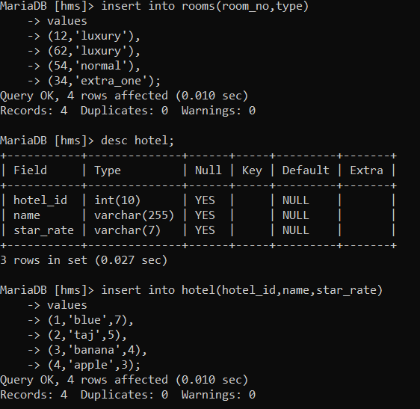

**DATA UPDATION**

select * from hotel;

+----------+--------+-----------+

| hotel_id | name | star_rate |

+----------+--------+-----------+

| 1 | blue | 7 |

| 2 | taj | 5 |

| 3 | banana | 4 |

| 4 | apple | 3 |

+----------+--------+-----------+

4 rows in set (0.000 sec)

MariaDB [hms]> update hotel

-> set name='banana_hotel'

-> where hotel_id=3;

Query OK, 1 row affected (0.002 sec)

Rows matched: 1 Changed: 1 Warnings: 0

MariaDB [hms]> select * from rooms;

+---------+-----------+

| room_no | type |

+---------+-----------+

| 12 | luxury |

| 62 | luxury |

| 54 | normal |

| 34 | extra_one |

+---------+-----------+

4 rows in set (0.000 sec)

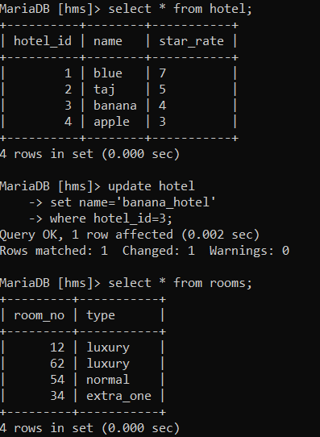

MariaDB [hms]> select * from rooms;

+---------+-----------+

| room_no | type |

+---------+-----------+

| 12 | luxury |

| 62 | luxury |

| 54 | normal |

| 34 | extra_one |

+---------+-----------+

4 rows in set (0.000 sec)

MariaDB [hms]> update rooms

-> set type='extra_lux'

-> where room_no=12;

Query OK, 1 row affected (0.012 sec)

Rows matched: 1 Changed: 1 Warnings: 0

MariaDB [hms]> SELECT * FROM ROOMS;

+---------+-----------+

| room_no | type |

+---------+-----------+

| 12 | extra_lux |

| 62 | luxury |

| 54 | normal |

| 34 | extra_one |

+---------+-----------+

4 rows in set (0.000 sec)

